VEX IQ Level Up: Session 3 - Scoring Test
Activity: Score a Bean Bag on a L1 Goal!
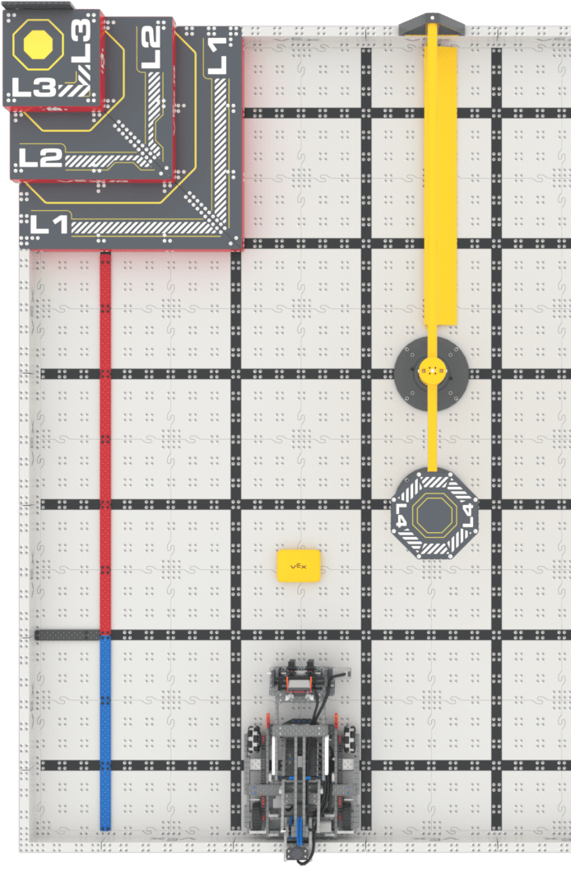
- Set up for the activity:
  - Make sure the Controller is paired with the robot. Use the information in this article to help you.
  - Set up your field as shown in the image to the right.
  - Start the Drive program on the VEX IQ Brain.
    - Control Flop’s intake using the R buttons.
    - Control Flop’s arm using the F buttons.
- You will test all four drive configurations and see how long it takes to score the Bean Bag on a L1 Goal.
  - Time how long it takes for you to gather the Bean Bag, drive towards the Pyramid Goal, and then score the Bean Bag on the L1 Goal.
  - Record any other notes about the task.
- Place Flop and the Bean Bag back to their same starting positions. Repeat the test with each of the four drive configurations.
  - Record the time and notes for each driver configuration.

Example Documentation: On the following page.

Feeling Stuck?
- Slow down and practice controlling Flop’s arm and intake before beginning the task.

Discussion Questions  - What do you like about each drive mode?  - What do you dislike?  - Which of the four drive modes makes the arm and intake the easiest to control?  - How can you improve your driving or documentation skills? | Activity Checklist  - Each team member scored the Bean Bag on the L1 Goal with all four configurations.  - Each team member recorded drive data in the engineering notebook.

Example Documentation

Remember, this is just one way to document your data. Document in the way that works best for you!

Task: Score a Bean Bag on a L1 Goal!

Driver | Configuration | Joystick Controls | Time
Lauren | Tank Drive | 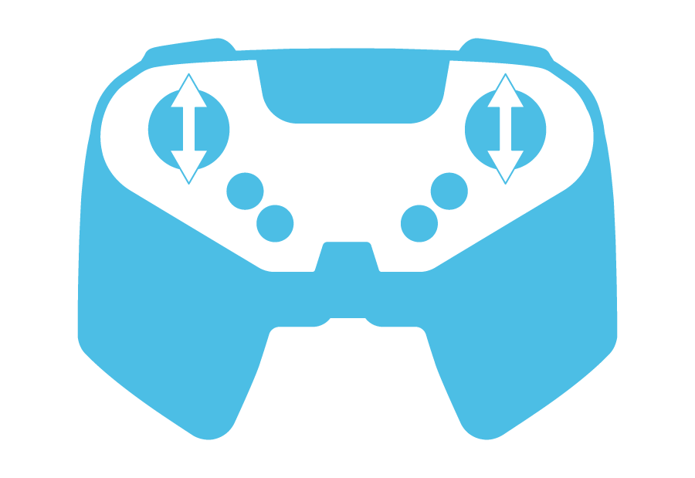  Left motor with left joystick  Right motor with right joystick | 40 seconds
Lauren | Notes:
Lauren | Left Arcade
Lauren | Right Arcade
Lauren | Split Arcade

